Lab 7 Report Template

**Given a string S and a key string P, encode and decode the string S, using the key string P .**

1. **P as integer, to XOR every charactor to encode and decode**
   1. In fact, when I begin to use some mathematic methods to encode a character, I need to change it into a number by ASCii or something else. However, in this question, the string P is an integral string, which means that step is not necessary.
   2. I get the character form P and S in turn and I encode them by using ASCii, then they will be used in the calculation:

(Pitem XOR Sitem). Then I decode the result with ASCii.

* 1. In the decode function, the operations are same to the encode function.
  2. Code in Python :

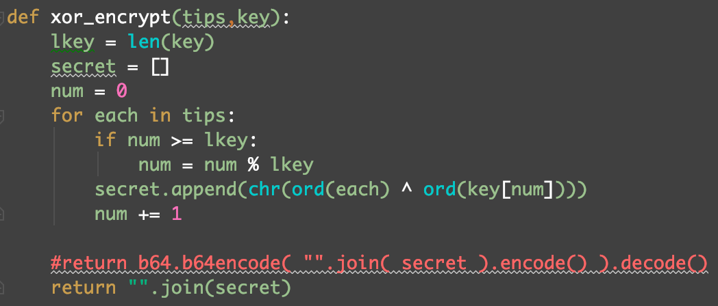

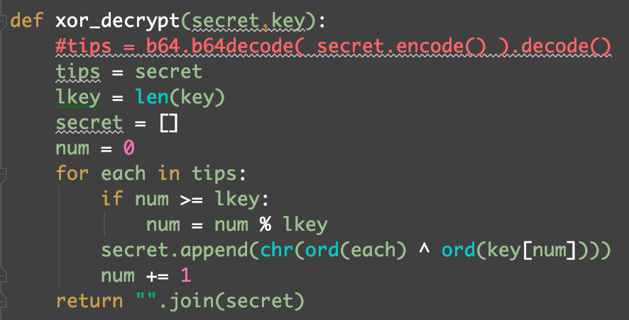

* 1. Test :

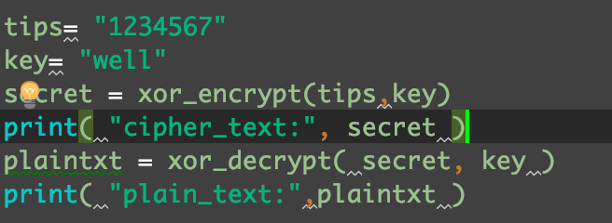

Output:

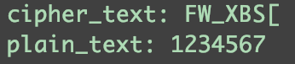

1. **P as string, to ADD every charactor to encode and SUB every charactor to decode for every substring of S at the length of P.**

2.1 In fact, the differences between question 1 and question 2 are very small. And I just change 2 XOR character into 1 ADD and 1 SUB in the tow functions.

2.2 Code in Python :

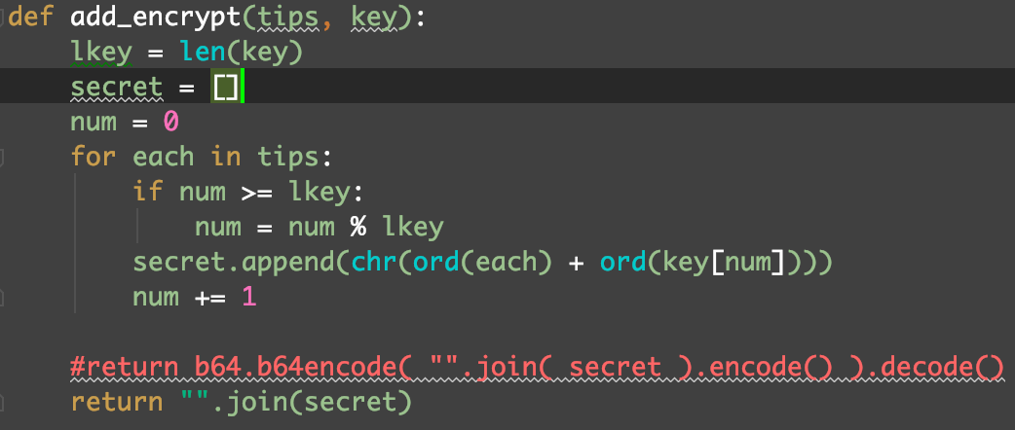

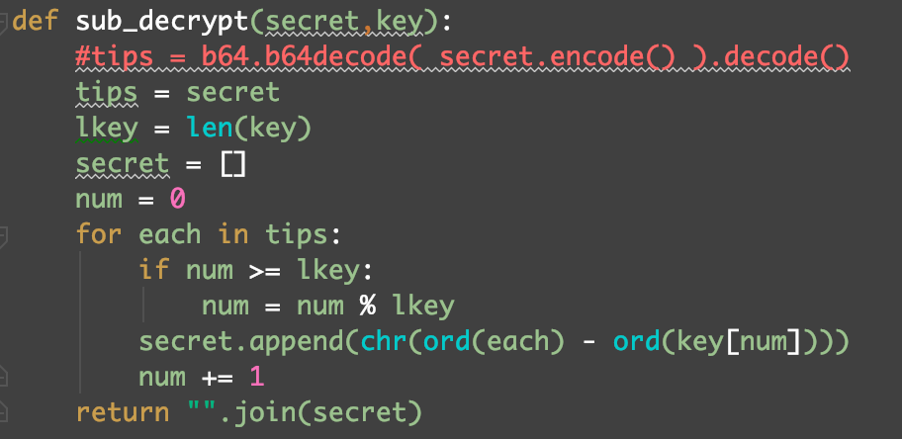

2.3 Test :

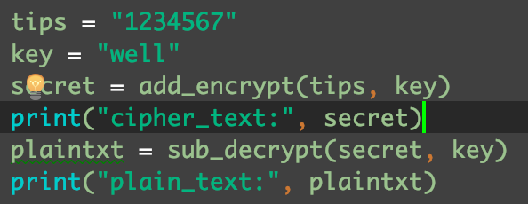

Output :

